Northwest District

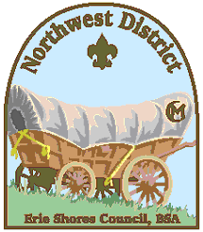

**Award Nomination Form**

**PACK/TROOP/CREW/POST**

**COMMITTEE MEMBER OF THE YEAR**

Name of Volunteer:__________________________________ Unit: _________

Years of Volunteer Service w/BSA_____________ Pack Troop Crew Post

Trainings Completed: ______________________________________________________

Other positions held in BSA________________________________________________

_______________________________________________________________________

Person submitting nomination :(Optional)_________________________________________

Briefly describe what traits this person displayed as a volunteer: ___________________

_______________________________________________________________________

_______________________________________________________________________

How did this person uphold the values of Scouting?______________________________

_______________________________________________________________________

_______________________________________________________________________

How did this person display their Leadership? __________________________________

_______________________________________________________________________

_______________________________________________________________________

Other information or volunteer positions: ______________________________________

_______________________________________________________________________

_______________________________________________________________________

***Please submit to Scout Service Center or e-mail to:***

**Northwest District:** [**pat.keenan@scouting.org**](mailto:pat.keenan@scouting.org) **(OR)**

**Northwest District Commissioner:** [**amroz@bex.net**](mailto:amroz@bex.net)